A Report
on
A Workshop
“Engineering Projects using Arduino”

Jointly organized by
Institution’s Innovation Council of Shri Guru Gobind Singhji Institute of Engineering and Technology, Nanded
and
Department of Electrical Engineering, Government Polytechnic, Nanded

Day and Date
Monday & Tuesday and 19 & 20-Dec-2022
Venue
Lecturer Hall, Department of Electrical Engineering, Government Polytechnic, Nanded

Faculty involved: Dr. S.S. Gajre, Dr. R.R.Manthalkar

Institutions Innovation Council of Shri Guru Gobind Singhji Institute of Engineering and Technology, Vishnupuri, Nanded and Department of Electrical Engineering, Government Polytechnic, Nanded jointly organized Two-day workshop on 'Engineering Projects using Arduino' on 19th and 20th December,2022 at Government Polytechnic, Nanded.
Prof.S.S.Gajre (Coordinator), Prof.R.R.Manthalkar (Co-cordinator), and Adarsh Bhosale(Students Ambassador), Pragati Darekar (Students Ambassador) from IDEA Lab, Nipun Dhandage (RNXG), and, Aniket Shikarkhane, Ayush Meshram, Hindavi Landhe, etc Students from SGGSIET were present for the events. Prof. Vilas Sarwadnya, Prof. Abhilasha Sayar, Prof. P.S. Linge, Prof. Faimid Abdul, Prof. Y.S.Katake, Prof. O.M. Chavan, Prof. Priya B. Khedkar were present. Students from Department of Electrical Engineering, Government Polytechnic, Nanded actively participated in the workshop.
Prof.S.S.Gajre took the opportunity to invite the faculty and students of Government Polytechnic to IDEA Laboratory to complete engineering projects and participate in other events. Prof. R.R.Manthalkar advised the students to utilize the time for study during their life. Basics Electronics Engineering, Sensor and Transducer, Basics of C-programming were taught on the first day while on the second day hands-on on Arduino were arranged. Also, academic projects were discussed during the workshop. The workshop ended with a concluding remark from Prof. Vilas Sarwadnya.
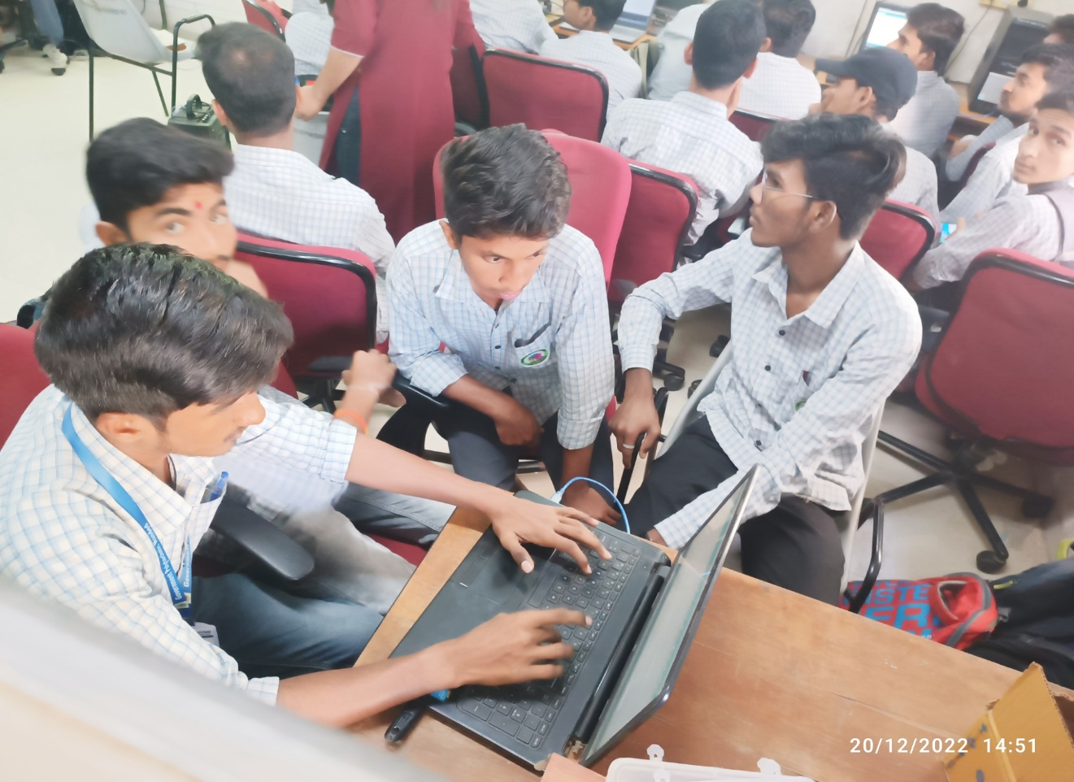
Students performing activities of workshop.

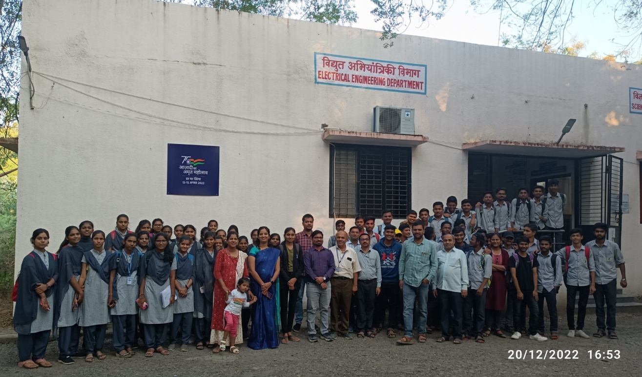
Group Photo of students attended the workshop

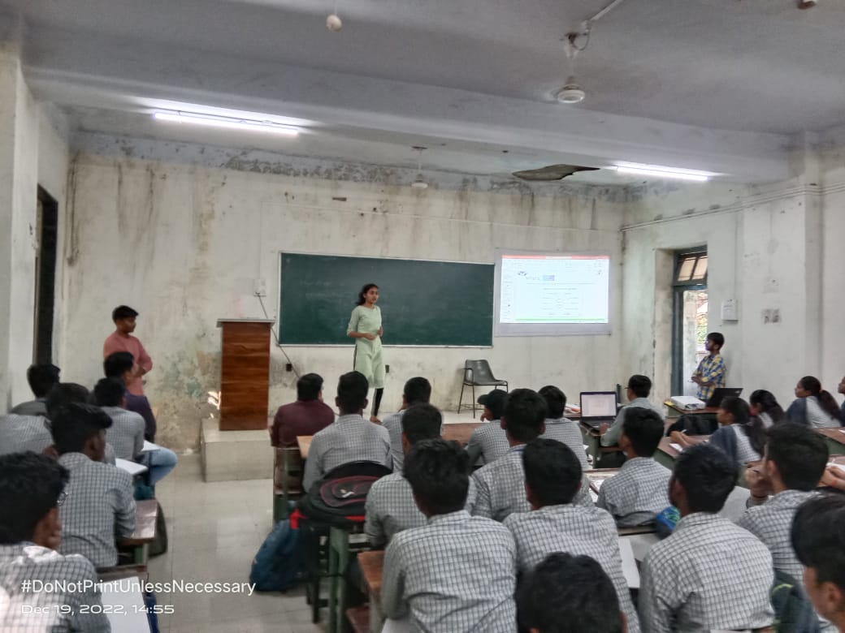
Students attending the session

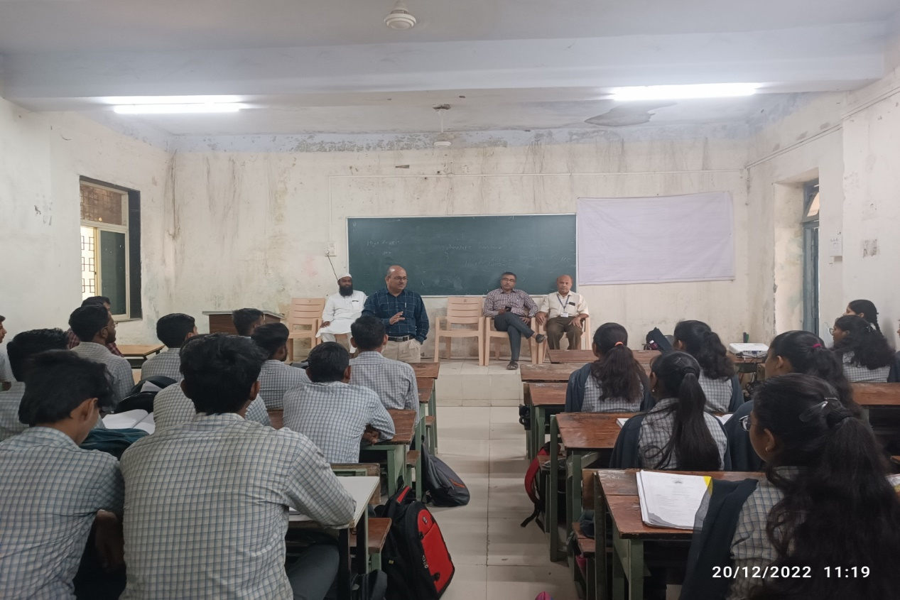
Dr. S.S. Gajre taking the opportunity to invite the faculty and students of Government Polytechnic to IDEA Laboratory

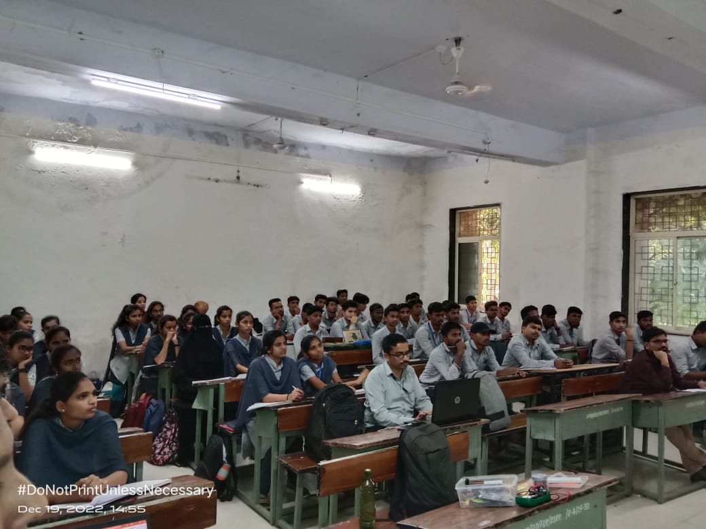
Students attending the session

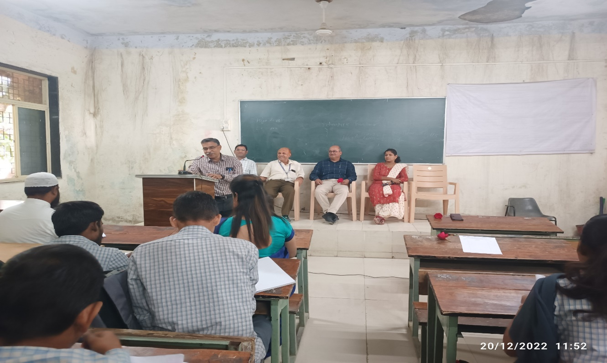
Dr. R.R.Manthalkar advised the students to utilize the time for study

