**Shri Guru Gobind Singhji I.E. & T, Nanded**

**Department of Electronic & Telecommunication Engineering and**

**Department of Textile Technology**

Organizes

**TEQIP Faculty Development Program**

**On**

**Research Methodology: Tools and Techniques**

**March 11-15, 2013**

**Dr. R. N. Joshi Dr. S. S. Gajre Dr. L. M. Waghmare**

**Coordinator Coordinator Director**

**TEQIP Sponsored One Week Interdisciplinary FDP on**

**“Research Methodology: Tools & Techniques”**

**11th-15th March 2013**

***Programme Schedule***

|  |  |  |
| --- | --- | --- |
| ***Day 1: 11/03/2013,Monday*** | | |
| 9.30-10.30 | Registration & Breakfast | Expert faculty |
| 10:30-12:00 | **Inauguration starts at 10.30 a.m.**  Importance of research in Institutes’ academic development | Prof B M Naik,  *Ex. Principal, SGGS* |
| 12:15-13:45 | Research Methodology: A creative approach | Dr R R Manthalkar,  *Prof & Ex Head, SGGS* |
| 14:30-16:00 | Mind set in creative thinking | Dr. Prabir Kar,  *Prof & HOD Textile Tech* |
| 16:15-17:45 | Mathematics for research | Dr A R Patil, *Asso. Prof. of math* |
| ***Day 2: 12/03/2013,Tuesday*** *()* | | |
| 10:30-12:00 | Research in an Indian Perspective | Prof R G Jamkar, *Asso. Prof. Inst.* |
| 12:15-13:45 | LATEX-DTP for thesis writing | Prof. R. S. Mangrulkar,  *Head, B.D.C.O.E Wardha* |
| 14:30-16:00 | LATEX-DTP for thesis writing | Prof. R. S. Mangrulkar |
| 16:15-17:45 | Literature survey & writing of good research papers | Dr. B. M. Patre,  *Prof. & Ex. Dean, SGGS* |
| 17.45 | **Group photo in front of Admin building** |  |
| ***Day 3: 13/03/2013, Wednesday*** | | |
| 10:30-12:00 | Use of SPSS in regression analysis | Dr. R. N. Joshi, *Asst. Prof of Textile, SGGS* |
| 12:15-13:45 | Design of experiment | Dr B M Dabade,  *Prof & Acting Director of SGGS* |
| 14:30-16:00 | Research funding & e-resources | Dr B M Patre, *Prof. of Inst. SGGS* |
| 16:15-17:45 | Role of experimentation in engineering research | Dr S B Sharma,  *Prof. & Dean SGGS* |
| ***Day 4: 14/03/2013, Thursday*** | | |
| 10:30-12:00 | An overview of research process | Dr. D. K. Nauriyal,  *Professor, IIT Roorkee* |
| 12:15-13:45 | Parametric and non-parametric tests | Dr. S. P. Singh, *Professor, IIT Roorkee* |
| 14:30-16:00 | Methods of data collection | Dr. D. K. Nauriyal |
| 16:15-17:45 | Parametric and non-parametric tests | Dr. S. P. Singh |
| ***Day 5: 15/03/2013,Friday*** | | |
| 10:30-12:00 | Research report/thesis organization and writing | Dr. D. K. Nauriyal |
| 12:15-13:45 | Statistical analysis & interpretation | Dr. S. P. Singh |
| 14:30-16:00 | Research report/thesis organization and writing | Dr. D. K. Nauriyal |
| 16.00-17.30 | Statistical analysis & interpretation | Dr. S. P. Singh |
| 17.30-17:45 | Valedictory | Dr. L. M. Waghmare, *Director, SGGS* |

**List of participants for Research Methodology: Tools & Techniques**

**SGGSIE&T Nanded (11-15 March 2013)**

|  |  |  |  |  |
| --- | --- | --- | --- | --- |
| SR | Name Of The Participants | College Name | Cell | E-Mail |
| Mr. | Ravindra Harishchandra Adekar | STBCOE, TULJAPUR | 9860460302 | [rh_adekar@rediffmail.com](mailto:rh_adekar@rediffmail.com) |
| Mr. | Badekar Shivaji Govindrao | GP, NANDED | 9421335290 | shivajibadekar@gmail.com |
| Mr. | Vithal Rajendra Bhandare | GOA,COP | 9822122226 | karzer@rediffmail.com |
| Ms. | Bhoodevi P. Bhandare | PDACOE GULBARGA | 9481644867 | bpbhandare13@rediffmail.com |
| Mr. | Krishnakant B. Bhelkar | GCP NAGPUR | 9975452155 | krishnakant_bhelkar@  rediffmail.com |
| Mr. | Bhuktare Sanjay Ganpatrao | SSIP PARBHANI. | 9890605478 | bhuktaresg@gmail.com |
| Mr. | Milind Rajabhau Bongulwar | GCOE&R,AWASARI | 9370322479 | milindbongulwar@hotmail.com |
| Mr. | Mallappa A. Devani | BKIT BHALKI | 9480757320 | mdevani003@gmail.com |
| Mr. | Dhadwe Avinash Kishanrao | NPC,NANDED | 8087255108 | adhadve@gmail.com |
| Ms. | Dhane Rupalee Manohar | NPC,NANDED | 9673542751 | rupaleeshinde09@gmail.com |
| Mr. | Dhoot Shailesh Brijkishor | NPC,NANDED | 9422871734 | sbdhoot@rediffmail.com |
| Mr. | Kalpesh S. Dongre | BNCOE, PUSAD | 9420047047 | kalpesh_dongre@rediffmail.com |
| Mr. | Fernandes Adison | GOA,COP | 9970371512 | adison.fernandes@gmail.com |
| Mr. | Firke Sagar Nareshrao | NPC,NANDED | 9665993927 | sagar1385@yahoo.co.in |
| Mr. | Ghainwad Mohan Laxmanrao | NPC,NANDED | 9860937873 | mohanghainwad@yahoo.in |
| Mrs. | Ghadge Chhaya Arjun | STBCOE, TULJAPUR | 9890976305 | ghadge.c@rediffmail.com |
| Mr. | Ghante Mahavir | NPC,NANDED | 8007777151 | mhghante@gmail.com |
| Mr. | Gulshan A. Gurunani | GCP NAGPUR | 8275298312 | gurugul@yahoo.co.in |
| Mr. | Halge Anil Janardhan | SSIP PARBHANI. | 9860495147 | halge_anila@rediffmail.com |
| Mr. | Hangargekar Pradeep Abasaheb | STBCOE, TULJAPUR | 9822329193 | pahh@rediffmail.com |
| Mr. | Hasarmani Totappa Shivlingappa | BVLTC,MULSHI | 9975120933 | santosh_hasarmani@rediffmail.com |
| Mr. | **Jadhav** Dattatray Bhagawan | BVDUCOE,PUNE | 9960607745 | [djmech2009@gmail.com](mailto:djmech2009@gmail.com) |
| Mr. | Jadhav Pramod Pandurang | BVDUCOE,PUNE | 9922636939 | [sayhipramod@rediffmail.com](mailto:sayhipramod@rediffmail.com) |
| Mr. | Jagtap Tatyasaheb Narsing | STBCOE, TULJAPUR | 9422467626 | tn.jagtap@rediffmail.com |
| Mrs. | Munira A. Jiwani | BNCOE, PUSAD | 9420682288 | majiwani@rediffmail.com |
| Mr. | Kadam Balasaheb Vasantrao | BVDUCOE,PUNE | 9860144977 | bv_kadam@yahoo.com |
| Mr. | Kadam Sunil Jagannath | BVDUCOE,PUNE | 9960108842 | s.kad@rediffmail.com |
| Mr. | Kagade V. R. | STBCOE, TULJAPUR | 9881396995 | vijaykagade@rediffmail.com |
| Dr. | Kalamse Vaman Manikrao | NPC,NANDED | 9960114524 | kaivalyachaya@gmail.com |
| Mr. | Kale Yogesh Sampatrao | BVLTC,MULSHI | 9527914800 | kaleyogeshs@gmail.com |
| Mr. | Kandhare Sanjay Madhavrao | GP, NANDED | 9422657544 | kandharesm68@gmail.com |
| Dr. | John U. Kennedy | PDACOE GULBARGA | 9449638617 | jukennedy@gmail.com |
| Mr. | Kharche Wasudeo Gajanan | BVJNIT PUNE | 9420564234 | wgkharche@yahoo.com |
| Mr. | Khumane Dhananjay Dattatray | STBCOE, TULJAPUR | 9421956393 | d_khumane@rediffmail.com |
| Mr. | J. Naveen Kumar | BVDUCOE,PUNE | 9096965493 | naveenkumar@bvucoep.edu.in |
| Mr. | Anand Rameshrao Lolge | GP,HINGOLI | 8149188844 | anand_lolge@yahoo.co.in |
| Mr. | Mudkanna Ravindranath Gurushantappa | STBCOE, TULJAPUR | 9423816979 | omravi111@rediffmail.com |
| Mr. | Kalpesh B. Narvenkar | GP CURCHOREM | 9765788335 | kalpsi@rediffmail.com |
| Mr. | Sharanabasappa B. Patil | PDACOE GULBARGA | 9483452102 | sbpcct@gmail.com |
| Mr. | Vinod Hanmant Patil | BVDUCOE,PUNE | 9975720716 | vhpatil@bvucoep.edu.in |
| Mr. | Patil Prasad B. | BVDUCOE,PUNE | 7875732499 | [pbpatil@bvucoep.edu.in](mailto:pbpatil@bvucoep.edu.in) |
| Mr. | Pokale Laxmikant Gangadharrao | SSIP PARBHANI. | 9423444438 | poklvrss@gmail.com |
| Mr. | Potdar Vaibhav V. | GOA,COP | 9420039461 | pvv1@rediffmail.com |
| Mr. | Puhlwale Balvant Shivharrao | GP, NANDED | 9096270174 | balvant.phulwale@gmail.com |
| Mr. | Ashish Babanrao Roge | NPC,NANDED | 9503887319 | ashish_roge@rediffmail.com |
| Mr. | R. M. Sangshetty | PDACOE GULBARGA | 9902566241 | rmspda@yahoo.co.in |
| Mr. | Sarje Shrinivas K. | NPC,NANDED | 9822671619 | shriniwas.sarje@gmail.com |
| Mr. | Sarje Hemant Kondiba | FTC COER,SANGOLA | 9823028500 | hemantsarje@gmail.com |
| Dr. | G. R. Shendarkar | NPC,NANDED | 9730680030 | gshendarkar@gmail.com |
| Mrs. | Kavita Santosh Shiktode | SNDT JUHU | 9967112738 | kshiktode@gmail.com |
| Mr. | Sonawane Mahendra Haribhau | BVDUCOE, PUNE. | 9422309488 | sonmalhar@gmail.com |
| Mr. | Suryawanshi Pradeep Tatayarao | STBCOE, TULJAPUR | 9422115231 | pts_stb@rediffmail.com |
| Mr | Sutar Bajrang Hanamant | BVDUCOE, PUNE. | 9822547748 | [sbajarang@hotmail.com](mailto:sbajarang@hotmail.com) |
| Mrs | Pushpa B.Patil | BLDEA BIJAPUR | 9480090496 | [pushpu-mj@rediffmail.com](mailto:pushpu-mj@rediffmail.com) |
| Prof | Aparna B.Dalvi | SEC WASHIM | 9420529852 | [hod-electrical@sanmati.in](mailto:hod-electrical@sanmati.in) |
| Dr | Prashant.G.Kamble | PDACOE GULBARGA | 9448405573 | [kprashantg1@gmail.com](mailto:kprashantg1@gmail.com) |
| Dr | Sachhidanand Reur | PDACOE GULBARGA | 9448043179 |  |
| Prof. | Vinayak G. Asutkar | SGGSIE&T NED | 9422896623 | [vgasutkar@yahoo.com](mailto:vgasutkar@yahoo.com) |
| Prof. | Bainwad Anant Madhavrao | SGGSIE&T NED | 9860998863 | [ambainwad@sggs.ac.in](mailto:ambainwad@sggs.ac.in) |
| Prof. | Balaji R. Bombade | SGGSIE&T NED |  | [b.r.bombade@gmail.com](mailto:b.r.bombade@gmail.com) |
| Prof. | R. K .Chavan | SGGSIE&T NED | 9011518506 | [rkchavan@sggs.ac.in](mailto:rkchavan@sggs.ac.in) |
| Prof. | Sanjay B. Dethe | SGGSIE&T NED | 9421295536 | [sanjaydethe@gmail.com](mailto:sanjaydethe@gmail.com) |
| Prof. | Shashikant C. Dhawale | SRTMU NANDED |  | [shashiprathmesh@gmail.com](mailto:shashiprathmesh@gmail.com) |
| Prof. | Mahendra S .Gaikwad | SGGSIE&T NED | 9096674539 | [mahendra14g@gmail.com](mailto:mahendra14g@gmail.com) |
| Prof. | Gopchade Santosh | SGGSIE&T NED | 9890738807 | [gopi_kishan0077@rediffmail.com](mailto:gopi_kishan0077@rediffmail.com) |
| Prof. | Hatkar S. S | SGGSIE&T NED | 9421868526 |  |
| Prof. | P.G Jadhav | SGGSIE&T NED | 9421868758 |  |
| Prof. | Rahul Keshav Jadhao | SGGSIE&T NED | 9028836225 | [rahulkjadhao@yahoo.co.in](mailto:rahulkjadhao@yahoo.co.in) |
| Prof. | Tukaram Mohanrao Kalyankar | SRTMU NANDED | 8149026046 | [kalyankarr@rediffmail.com](mailto:kalyankarr@rediffmail.com) |
| Dr. | Katkhaye Sachin V | SGGSIE&T NED | 9403149872 | [sachinkatkhaye@gmail.com](mailto:sachinkatkhaye@gmail.com) |
| Prof. | Khandre Naresh Madhukarrao | SGGSIE&T NED | 9960136046 | [nmkhandre2004@yahoo.com](mailto:nmkhandre2004@yahoo.com) |
| Prof. | Mitkare Sachin Suryakant | SRTMU NANDED | 9423352371 | [sachinpharma08@gmail.com](mailto:sachinpharma08@gmail.com) |
| Dr. | Nalwade Prakash Shivajirao | SGGSIE&T NED | 9860720229 | [psnalwade@sggs.ac.in](mailto:psnalwade@sggs.ac.in) |
| Prof | Nandedkar Amit Vijay | SGGSIE&T NED | 9420848235 | [nandedkar_amit@yahoo.com,](mailto:nandedkar_amit@yahoo.com,) |
| Dr. | Nandeshwar V. J. | SGGSIE&T NED | 9403375310 | [vikasnandeshwar@gmail.com](mailto:vikasnandeshwar@gmail.com) |
| Prof. | Navdeti C. P. | SGGSIE&T NED | 9423422620 | [navdetichandrakant@gmail.com](mailto:navdetichandrakant@gmail.com) |
| Prof. | Pakle Ganseh K | SGGSIE&T NED | 9028992109 | [g.pakle@gmail.com](mailto:g.pakle@gmail.com) |
| Prof. | Rekha V. Pande | SGGSIE&T NED | 8087926516 | [pande.rekha@rediffmail.com](mailto:pande.rekha@rediffmail.com) |
| Prof. | Pekmwar Sanjay Sudhakar | SRTMU NANDED | 88889812736 | [sspekamwar@gmail.com](mailto:sspekamwar@gmail.com) |
| Prof. | Manik K. Rodge | SGGSIE&T NANDED | 9011888324 | [mkrodge64@rediffmail.com](mailto:mkrodge64@rediffmail.com) |
| Prof. | Sardare Amol Deorao | SGGSIE&T NED | 9860833973 | [amdsardare@gmail.com](mailto:amdsardare@gmail.com) |
| Prof. | S .B .Sharma | SGGSIE&T NED | 9422170323 | [sbsharma35@rediffmail.com](mailto:sbsharma35@rediffmail.com) |
| Dr. | Shetty Balaji S. | SGGSIE&T NED | 9270696267 |  |
| Dr. | Sudhakar V. | SGGSIE&T NED | 9403328165 | [sudhakar.vadicherla@gmail.com](mailto:sudhakar.vadicherla@gmail.com) |
| Prof. | Vinod B. Tungikar | SGGSIE&T NED | 9422870961 | [vbtungikar@gmail.com](mailto:vbtungikar@gmail.com) |
| Prof. | Aruna Narendra Vaidya | SGGSIE&T NED | 8600061281 | [arunavaidya55@gmail.com](mailto:arunavaidya55@gmail.com) |
| Prof. | Wankhade Lalit N. | SGGSIE&T NED | 9423438259 | [lalitwankhede@gmail.com](mailto:lalitwankhede@gmail.com) |
| Prof. | Vaidya M.V | SGGSIE&T NED | 9011050358 | [mvvaidya@gmail.com](mailto:mvvaidya@gmail.com) |
| Prof. | Hemant P.Ambulgekar | SGGSIE&T NED | 9860366220 | [ambulgekar@gmail.com](mailto:ambulgekar@gmail.com) |
| Prof. | Gouravkumar S. Malande | SGGSIE&T NED | 7588891051 | [gourao.malande@gmail.com](mailto:gourao.malande@gmail.com) |
| Dr. | L.G.Patil | SGGSIE&T NED | 9423441831 |  |
| Dr. | S.R.Butle | SRTMU NANDED | 9730774484 | [butlesr@gmail.com](mailto:butlesr@gmail.com) |
| Prof. | Subhash M.Birajdar | SGGSIE&T NED | 9403068317 | [smbirajdar@gmail.com](mailto:smbirajdar@gmail.com) |
| Mrs. | Jaishri.M.Waghmare | SGGSIE&T NED | 9423693802 | [jmwaghmare@sggs.ac.in](mailto:jmwaghmare@sggs.ac.in) |
| Prof. | Manisha S.Mahindrakar | SGGSIE&T NED | 9420020120 | [mnambekar@gmail.com](mailto:mnambekar@gmail.com) |

BRIEF CV’S OF SPEAKERS

|  |
| --- |
| **Prof. B. M. Naik**  Prof. B.M. Naik, Ex. Principal, 1983-1999, SGGSCE&T, Nanded  Governing Board Member, Govt engg college aurangabad  MCT’s Rajiv Gandhi Institute of Technology, Mumbai, Member (nominated by Trust) |

|  |
| --- |
| **Dr.  L.  M.  Waghmare**  **Education:** Ph.D in 2001 From IIT Roorkee, BE & ME From SGGS  **Awards and Honors**: K S Krishnan Award instituted by Institution of Electronics & Telecommunication (IETE), 2004, Certificate of Excellent Performance in 2007 by RODTE  **Membership and Fellowship:** IETE, IE, ISTE, IEEE, IS.  **Book Chapter**: Three  **Research:** 90+ publications in the national\international conferences, journals.  **Ph D Supervision:** Completed= 5, in progress= 7  **Administrative Responsibilities**  HOD Instrumentation, Dean (R&D) 2009-11, Dean (Academic) 2011-12, BOM member of SGGS, Dean (Faculty of Engineering and Technology), SRTMU, As Director: on 21/06/2012 for five year period). |

|  |
| --- |
| **Dr. Ramchandra R. Manthalkar Academic Qualifications**: BE 1988, ME1994, Ph. D. (IIT KGP) 2003  **Experience:** 25 years teaching, Working as a Professor in EXTC **Administrative Responsibilities:** HOD Extc 2009-12  **PG/Ph. D. Guidance:** Ph D=02, Progress= 03  **Publication:** journals= 11, Conf= 24  **Membership of Professional Bodies:** LM ISTE, LM BMESI, LM SSI, LM ISCEE |

|  |
| --- |
| **Dr Prabir Kar**  **Qualification:** Ph.D., M.Tech., B.Sc.(Tech)  **Work experience:** Teaching: 22 years, Research: 3 years, Industry: 3 years, Professor & Head  Of Textile Tech.  **Publications in Journals/ Conferences:** Journal- 07, Cof= 09  **Academic contribution:** Head of Department of Textile June 2012, Vehicle Running & Expenditure Monitoring Incharge Aug 2010  **Membership of Professional Bodies:** ISTE,Patron member of TAI |

|  |
| --- |
| **Arunkumar R. Patil**  **Education:** M. Sc./math, Ph.D. in Mathematics/ IIT Bambay  **Experience:** 1996-2013 Lecturer, AP, Associate Prof  **Awards:** Gold medal Marathwada University of Aurangabad, India  Teachers Fellowship from National Board for Higher Mathematics  **Publication:** 04  **Talks:** Indian Statistical Institute, North Maharashtra University, Jalgaon  AICTE recognized ISTE Short Term Training Programme |

|  |
| --- |
| **Dr. B. M. Patre**  **Education**: B.E & ME FROM SGGSIE&T, Ph.D IN 1998 From IIT,BOMBAY  **Experience**: Professor , Department of Instrumentation Engineering  **Membership And Fellowship**   Governing Council Member, Instrument Society of India, Fellow of Institution of Engineers, Member of IEEE (USA) , Member of IET ,Member of Institution  of Electronics and Telecommunication Engineers (MIETE), Life Member of ISTE, Life Member of Instrument Society of India  **Research:** Book:03, Book Chapter:04, Referred International/National Journals:32, Referred International Conferences:50, Referred National Conference: 16, Papers Communicated:21 **Ph D Supervision:** Completed= 9, in progress= 8  **Administrative Responsibilities:** HOD Instru 2009-11, Dean (R&D)  2005-09, Chairman Networking Cell, R&D Cell and III Cell of TEQIP-I, Chairman of Library Committee since 2003-09. |

|  |
| --- |
| **Prof R. G. Jamkar**  **Education:** B.E/1988, M.E/1994 From Marathwada University Aurangabad  **Experience:** Teaching 23 years, Associate Professor, Department of Instrumentation Engineering  **Membership Of Professional Bodies**: Life Member of ISTE and Instrumentation Society of India  **Other Activities:** Worked for Institute magazine, Utsav, many social programs. |

|  |
| --- |
| **Ramchandra S. Mangrulkar**  **Education:** M. Tech. NIT Rourkela, Ph. D. pursing . in Computer Science and Engineering  **Experience:** 12 years, working as Head of Computer Engineering Department, Bapurao Deshmukh College of Engineering, Sevagram from Oct 2010.  **Publication:** International Journals: (Total=10)   * + Conference: Total=21; International: 12; National: 09).   **Reviewer** of International Journal   * + Reviver of Journal of Network and Computer Applications (Elsevier)   **Expert Lectures delivered** at PIET, Nagpur. RCERT Chandrapur. J.D.I.E.T Yavatmal,   * + Latex and its use for Manuscript Preparation” |

|  |
| --- |
| **Dr. B.M. Dabade**  **Education**: B.E./1982/Vjti, M. Sc./ N. I. T. Rourkela, Ph.D./1998/I.I.T., Kharagpur  **Membership And Fellowship**: ISTE,ISME,MIE, BOM OF SGGS  **Books Chapter:**  Springer One  **Research:** 12  International Journals,18 Conferences,  **Phd  Guidance:** Completed= 08, In progress= 4  **Administrative Responsibilities:** Hod In Prod Engg= 07 Years, Acting Director Of Sggs In 2012 |

|  |
| --- |
| **Dr. S.B. Sharma**  **Education :** B.E/1985/GCOE Aurnagabad, ME/1994/IIT Khargapur, Ph.D. 2002 IIT Roorkee  **Awards And Honours:** Visit to UK : As a Research Fellow of the Royal Society,  **Membership And Fellowship:** Life member of ISTE,  **Books/Book: Chapter 1**  **Research:** 40+ Publications in the National/International conferences, journals.  **PhD: Completed= 2, In progress= 07**  **Administrative ResponsibilitieS**   Presently Dean (R&D), HOD production 2009-12, Head of Workshop (1994-1999 and Feb.2005-2009). |

|  |
| --- |
| **Dr. R. N. Joshi**  **Education:** B.Tech 1994, M. Tech, Ph.D. in 21010 from IIT Roorkee  **Experience:** Lecturer, Assistant Professor in SGGSIE&T from 1998--  **Publication**: [International Journal](https://sites.google.com/site/kailaswasewar/international-papers)  : 04**,** National Journal : **10,** International Conference:  **05**  National Conference      : 05**,**  **Invited Lecture As An Expert** : 03 |

**Dr S P Singh:**

Professor, Indian Institute Technology Roorkee

**Publications:** More than 100 papers in International and National Journals & conferences

Books: Two and three units on agricultural policy for IGNOU

**Membership of Professional Societies** Life member, Indian Society of Labour Economics, Indian Political Economy Association, Indian Institute of Public Administration, Indian Economic Association

**No. of Conferences organized:** 05

**No. of STTP organized :**  09

**Ph.D. Theses Supervised: Awarded 6 and 6 in progress**

**Major Research Projects: 06, Currently :** Team leader, Socio-economic and Cultural Theme of Ganga River Basin Environmental Management Plan, MOEF, GOI

**Other Achievements**

* Nominated by Ministry of Rural Development, Government of India as member of the Selection Committee constituted for giving recommendations to the State Government of Mizoram for appointment of the Ombudsman under MGNREGA for redressal of Grievances.
* Representing IIT Roorkee to the Professional Institute Network (PIN) constituted by the Ministry of Rural Development, Government of India to provide for steady and sustainable interventions to enhance the quality of the MGNREGS.

**Dr D. K. Nauriyal**

Professor, Indian Institute Technology Roorkee (working since 1988)

**Administrative Positions Held**:

* Chairman, Hospital Advisory Committee, Dean Student Welfare administration at the Institute for two terms. & other many posts, Head, Dept. of Humanities & Social Sciences

**Books Written:** Two

**Award:** Outstanding Teacher Award for 2012 conferred by IIT Roorkee

**Advisory Position(s):** Academic Advisor to Japan International Cooperation Agency (JICA) and Japan Bank for International Cooperation (JBIC) for the Dedicated Freight Corridor Project (Mumbai to Hawrah) costing Rs.22,000 crore. Responsible for studying the socio-economic aspects of Resettlement and Rehabilitation of the project affected population.

**Research Projects**: 07 major + 06 minor

**Under Progress:** Co-Investigator of the Socio-Economic-Cultural (SEC) component of ‘Ganga River Basin Management Plan’ being executed by the consortium of seven IITs

**Short -term Courses Organised**: 11

**Executive Development Programmes Organised:** 11

**Ph. D. Supervising:** Awarded: 09, On-going: 06

**Conferences /Workshops Organised**: : 04

**Conferences Attended (International/National):** Over 50.

**Consultancy projects Completed**: 21

**Editor:** Two Indian Journals & Membership of Professional Bodies: many associations

**Films for UGC Sponsored Country Wide Classroom:** Documentaries on: 'Flora and Fauna of Central Himalayas' 1998, and 'Himalayas: Swami Sunderanand Ki Aankho Se' 1998

**Selected Published Research Papers**: 38 referred journals

**Any Other important information:**

a. One of the members of the Vision 2020 Team, Member of the BOS & RRC various Indian Universities, c. Expert in the faculty selection committees of various Indian universities and Institutes, d. Expert in the selection committees of MHRD, Government of India, for the fellowships/scholarships of the foreign governments.

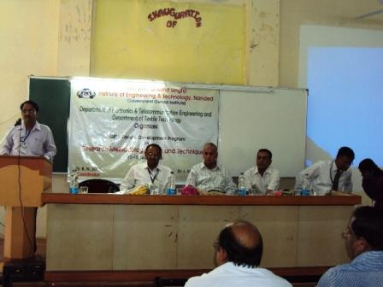

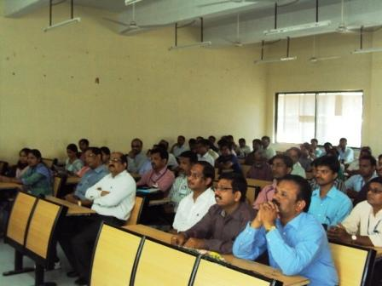

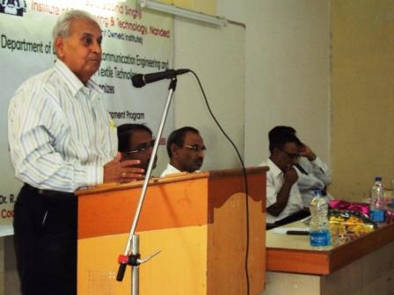

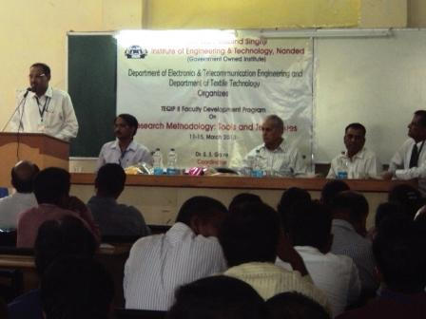

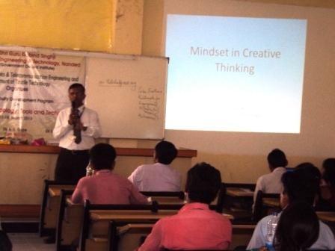

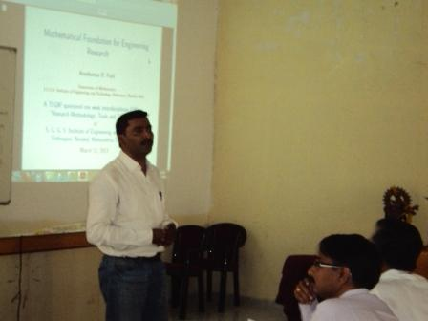

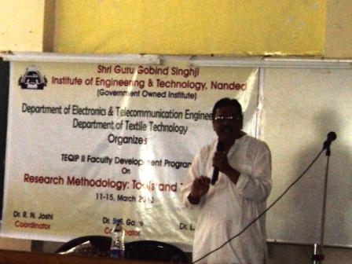

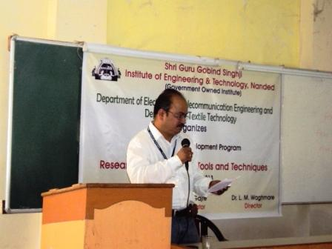

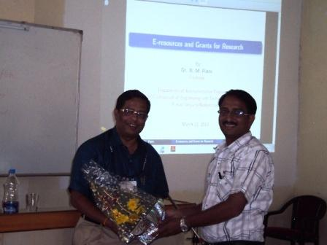

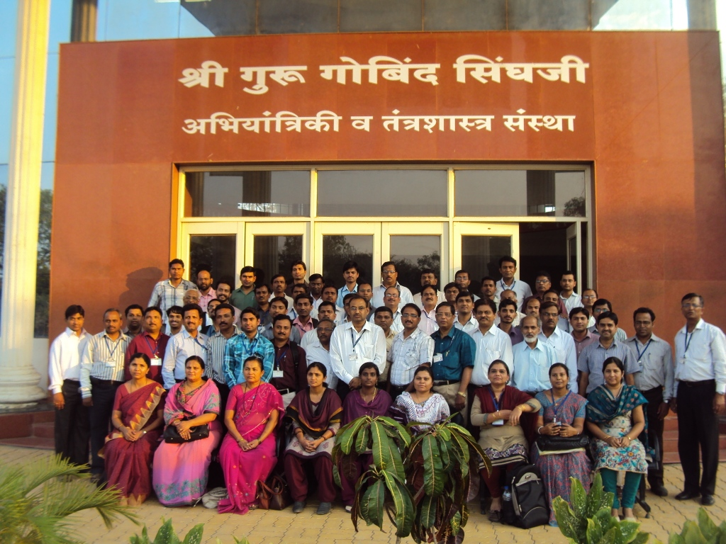

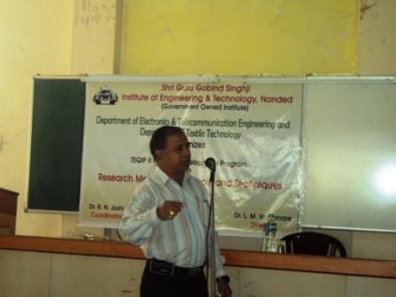

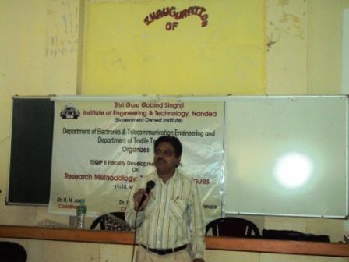

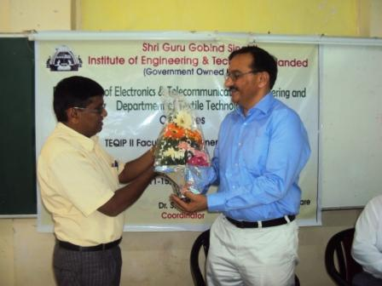

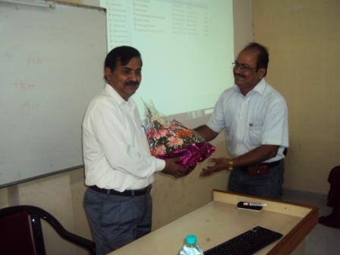

|  |  |  |  |  |
| --- | --- | --- | --- | --- |
|  | sggslogo | **Shri Guru Gobind Singhji  Institute of Engineering and Technology**  **Vishnupuri, NANDED (Maharashtra State) PIN 431606 INDIA**  (*Government Owned Autonomous Institute cent-percent funded by Govt. of Maharashtra*) |  | TEQIP Phase-II |

|  |  |  |  |  |  |  |  |  |
| --- | --- | --- | --- | --- | --- | --- | --- | --- |
|  |  | | **Technical Education Quality Improvement Programme (TEQIP)** | | | |  |  |
|  |  | |  | | | |  |  |
|  |  | | **One-week Interdisciplinary Faculty Development Programme on**  ***“Research Methodology: Tools & Techniques”***  **March 11-15, 2013** | | | |  |  |
|  |  | |  | | | |  |  |
|  |  | | This is to certify that, Dr./Mr./Ms./Mrs. ______________________________________ of ______________________________________________________________________ has attended one-week interdisciplinary (Engineering, Pharmacy and Management) Faculty Development Programme on *“Research Methodology: Tools & Techniques”* under TEQIP-II heldduring March 11-15, 2013 organized by the Department of Electronics and Telecommunication Engineering and Department of Textile Technology. | | | |  |  |
|  |  | |  | | | |  |  |
| Dr. S.S. Gajre | | Dr. R.N. Joshi | Dr. A.B. Gonde | Dr. L.M. Waghmare | | | |
| *Course Coordinator* | | *Course Coordinator* | *TEQIP Coordinator* | *Director* | | | |